**Advanced Algorithms**

**Exercise for Lecture 9**

|  |  |  |  |
| --- | --- | --- | --- |
| **Student Name** |  | **Student ID** |  |
| **Problem 1** |  | | |
| **Problem 2** |  | | |
| **Problem 3** |  | | |
| **Total Score** |  | | |
| **Notes** | Deadline: **2023-10-20 24:00**  Submission Format: ‘**Lecture9_Name_Student ID.docx**’, and please send to: **[chenlq1997@126.com](mailto:algorithms_23fall@163.com)**.  This assignment is meant to be an evaluation of your **individual** understanding coming into the course and should be completed **without collaboration** or outside help. | | |

**Problem 1.[30 points]**

1.1 Please show how to search 35 in the next skip list. Each comparison is an intermediate step, and you need to provide each step. The answer can be shown in one picture and the example is shown as follows:

1.2 Please show how to search 71 in the next skip list.

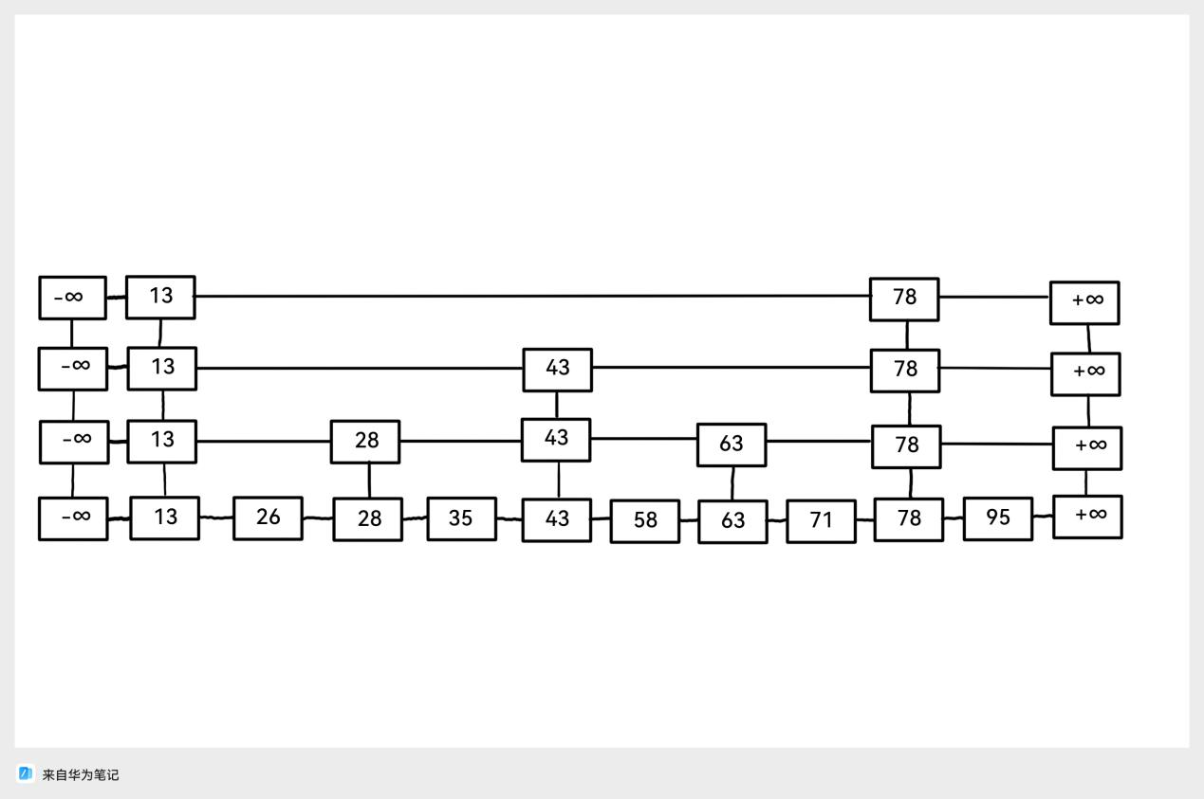

**Picture 1. The skip list**

**Search 13**

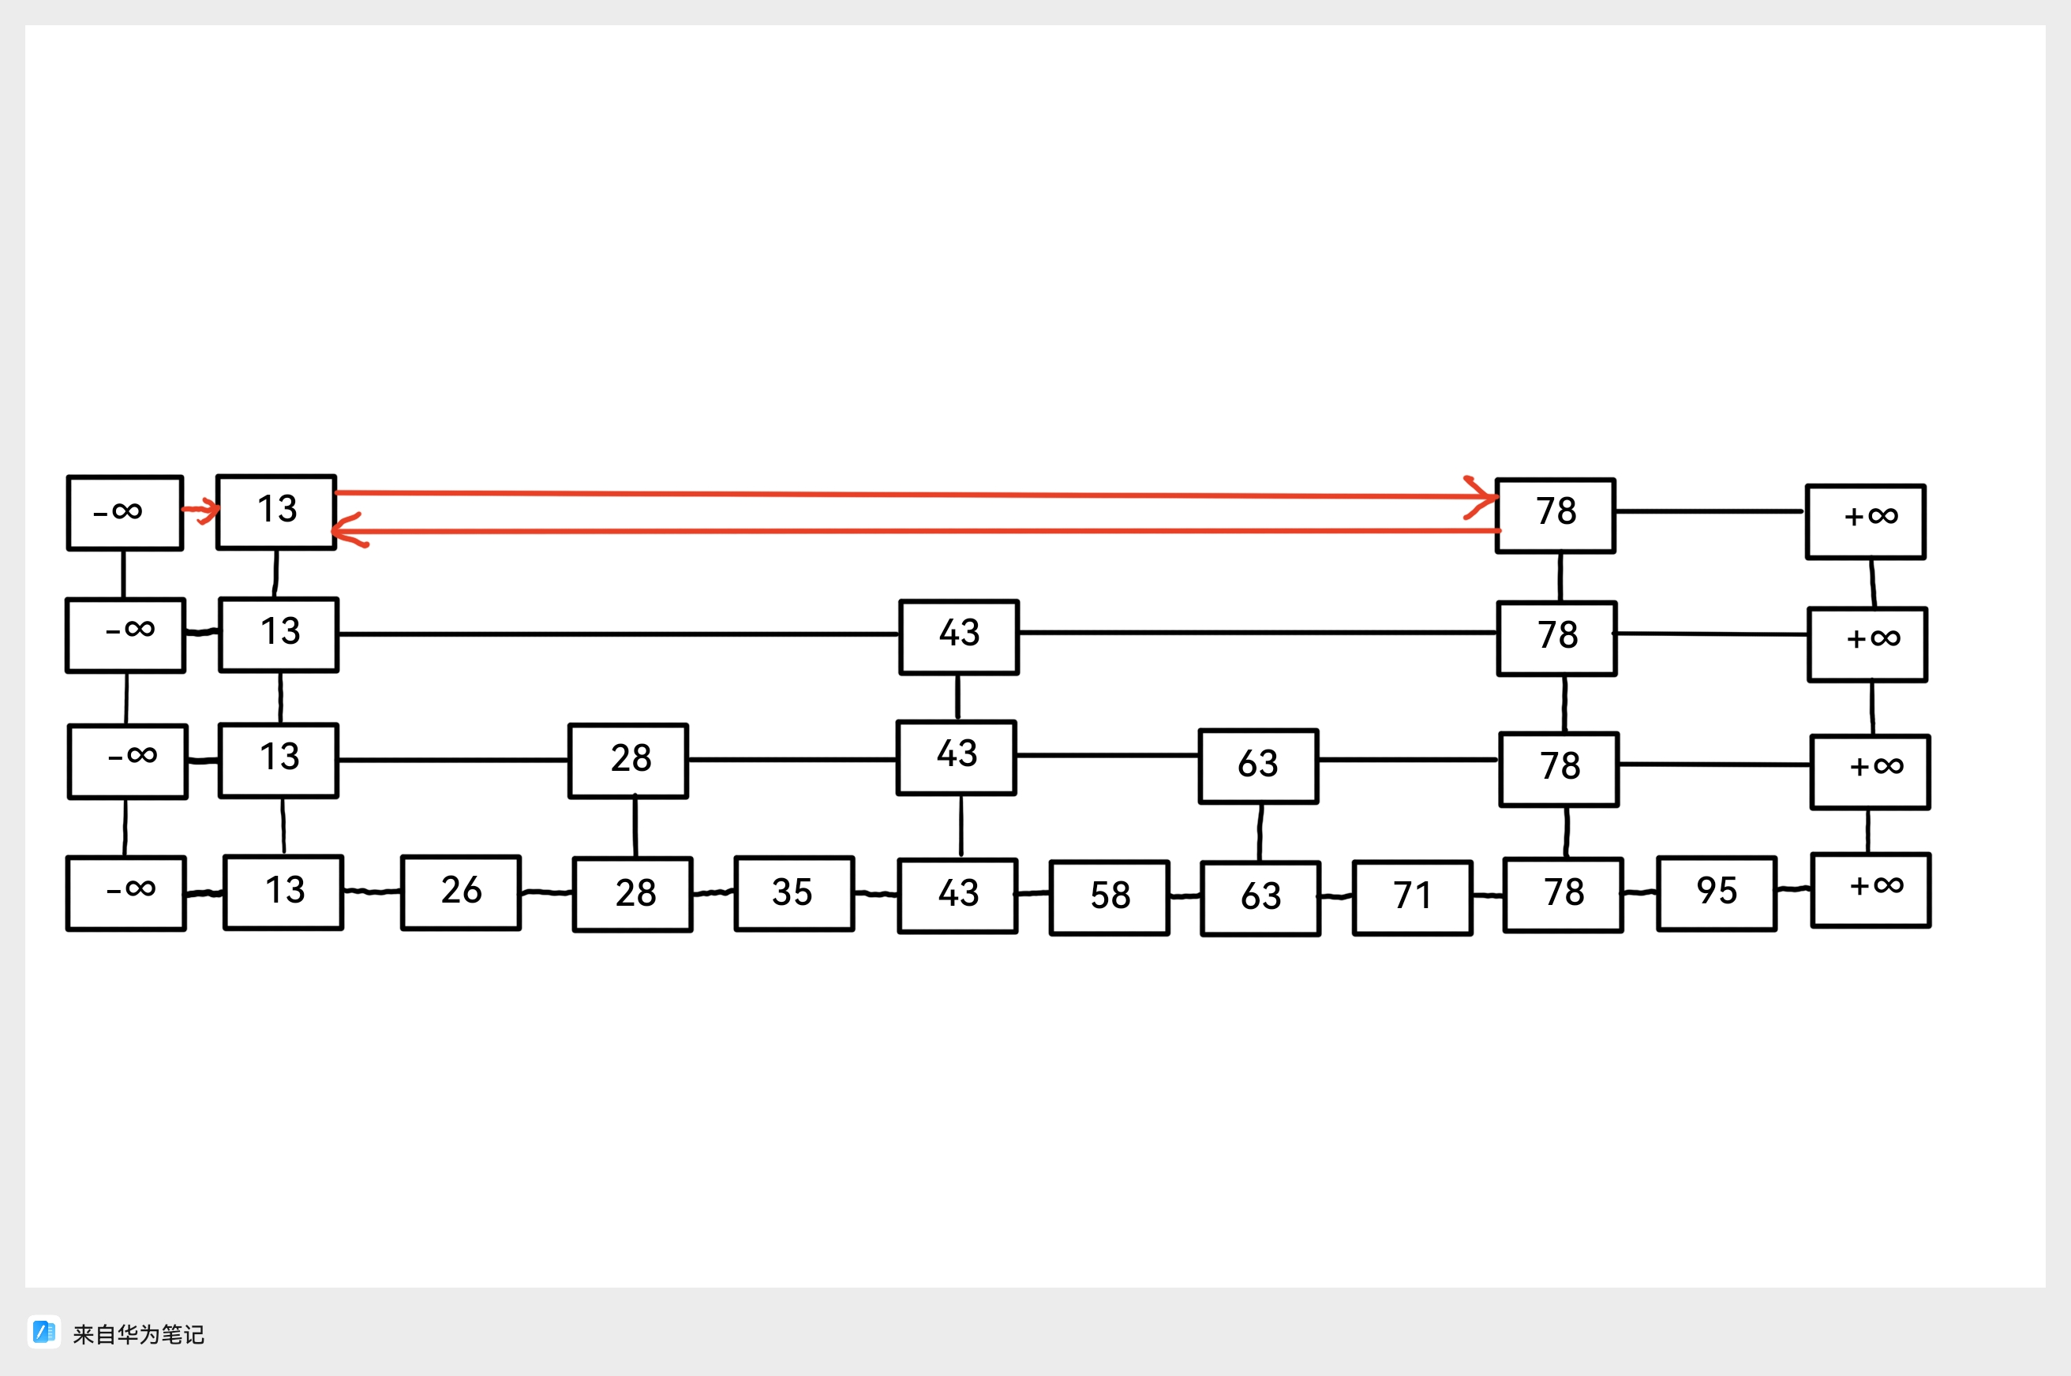

**Picture 2. The example of solution**

**Solution:**

**Problem 2.[30 points]**

2.1 Please design the data structure of the nodes in the skip list and the data structure of skip list separately.

2.2 Please give the code for searching operation in the skip list. Please give the effective C code directly instead of pseudo code whose name should be Skip_List_Search().

**Solution:**

**Problem 3.[40 points]**

You are need to give an algorithm to realize the following searching in an skip list: Given the key j and a pointer to the node $x$, and $x.key=i$. You need to find the node $y$ in $O(log k)$ expected time and $y.key= j$, where k is the distance between $x$ and $y.$

3.1 You are allowed to add an element to the data structure of the node and you need to explain the purpose of adding the new element.

3.3 Please introduce your algorithm.

3.2 Please analyse the time complexity of your algorithm.

**Solution:**